MIE354 - Assignment 1 - Coorest
Shreya Perumal
Anjali Jammulamadaka

Declaration of Generative AI Usage
“In submitting this Assignment 1, I confirm that the work I am submitting is the exclusive work of the students in my group, and that I made an equal contribution to the work of the group. I confirm that my conduct during this Assignment 1 adheres to the Code of Behaviour on Academic Matters. I confirm that I am abiding by the course policy regarding the use of Generative AI tools and that I did NOT act in such a way that would constitute cheating, misrepresentation, or unfairness, including but not limited to, using unauthorized aids and assistance, impersonating another person, and committing plagiarism. I pledge upon my honour that I have not violated the Faculty of Applied Science & Engineering’s Honour Code during this assessment.”

Course Policy
“Students are encouraged to make use of Generative artificial intelligence tools (e.g., Copilot, ChatGPT, or any other similar tool) to contribute to their understanding of course materials and to complete coursework submission in compliance with the general course instructions and any additional instructions provided in the coursework handouts. Students are ultimately accountable for the work they submit. The general instructions are that students must declare in their submissions the Generative AI tools that have been used and include a summary of how the tools have been used. Using Generative AI tools and failing to follow the required instructions can result in an "unauthorized assistance" academic offence.”

Release Statement
“I agree to make available my work developed through the course Assignments (not including my student name) for educational purposes.”

Files in Submission G04.zip
- G04-BPDescription.docx - Report of Business Process
- G04-BPModel.vsdx - Visio of Business Process
Table of Contents

1.0 Objectives, Customer, and Values 3
2.0 Process Scope and Process Instance 3
3.0 Textual BP Description 4
4.0 BP Diagram 5
5.0 Registry Use Description and Examples 6
6.0 Resource Classification Description 7
7.0 Activity Table 7
8.0 Web References 9
9.0 Generative AI Use 9

1.0 Objectives, Customer, and Values
Coorest’s objective is to provide a carbon capture and offset solution that is accessible to all while being profitable. Coorest provides customers (B2B and B2C) a carbon token purchase opportunity through “NFTrees”; at its core, they are tokens tied to real trees planted on lands owned by Coorest. When purchased, customers are issued a certificate detailing the location of the tree, breed, and CO² consumption to date. NFTree holders receive two streams of income: 1) 20% of sales from products produced by their tree(s) and 2) carbon mitigation tokens. Carbon mitigation tokens are issued to users as CO² mitigation data is verified. Users are then given the options to A) trade carbon tokens or B) burn their carbon tokens. When a token is burned, it means that the quantity of CO2 can no longer be released. After a token is burned, a user is provided with a Proof of Carbon Compensation (PoCC), containing the amount of CO², date of disposal, and location of the NFT that captured the carbon. To make this complex process work, Coorest works with Chainlink, FileCoin, and Polygon Pos, external organizations responsible for recording data, storing data and generating carbon tokens, respectively.

2.0 Process Scope and Process Instance
The process scope covers all the stages of the Coorest carbon mitigation cycle from NFTree purchase to carbon token retirement. The key functions of Coorest and all the external partners are as follows:
- Coorest: process owner, validates purchases/payouts, sends registry management requests.
- FileCoin: external registry storing tree ownership data, carbon statistics and carbon token data.
- Chainlink’s Oracle Floodlight: external network, provides relevant satellite data.
- Polygon POS: external blockchain network, validates and generates carbon tokens
Other activities non-essential to the fundament business process (such as tree planting, land maintenance, user platform, etc…) are excluded.

The process instance is one complete execution of the NFTree carbon compensation workflow for a specific customer (client or organizaion).
- Submit personal and purchase information for specific NFTree.
- Validate information and transfer ownership in FileCoin.
- Chainlink supplies carbon mitigation data and adds to data stores
- Coorest provides product sales data and conducts payout
- Polygon POS validates carbon mitigation and issues carbon tokens
- Instance concludes when tokens are burned or traded

3.0 Textual BP Description
Initially, all the trees are registered in the FileCoin registry with unique keys and the owner as Coorest (ex. (1, Coorest), (2, Coorest), etc…). The process starts with the purchase agreement, where a user will purchase an NFTree and provide their personal information and payment information. This information is then validated by Coorest to ensure that it is correct and complete. If the information is invalid, a resubmission will be requested. For a valid submission, the Filecoin registry is called to access the tree using its existing key and ownership is transferred (ex. (Tree1, Coorest) becomes (Tree1, Walmart)); once registered, a confirmation message is received.

Chainlink’s Floodlight Oracle is responsible for keeping track of the ecological data necessary to generate carbon tokens. Coorest requests environmental satellite data from Chainlink, which Chainlink then receives, and Coorest uses it to update the carbon mitigation for each tree in the registry. Additionally, the sales generated from the tree’s products are added to each tree’s respective registry. Once the sales are registered, 20% sales is calculated for each tree and a payout request is submitted. For example, if tree (Tree1, Walmart) is an apple tree and makes $200 in apple sales, the owner (Walmart) should be paid $40; thus, a payout request for the $40 was submitted. Once the payout request is issued, send a confirmation message to the owner.

The carbon mitigation data is then taken from the FileCoin registry and sent to the Polygon POS to validate the carbon data and avoid doubling tokens. Once tokens are validated, the registry is called to register a new token (tokenID, Owner). For example, when Walmart receives their carbon tokens, they will be registered as (Token1, Walmart), where tokenID is just a unique value. Once a token is issued for a carbon token, the owner is notified through a confirmation message and they receive their PoCC. If an owner wishes to burn their carbon token the registry will call unregister(tokenID) and the token will be removed. Alternatively when a user trades the token the registry will call transfer(tokenID, new owner), and the token will be traded to another party. For example, if Walmart has two carbon tokens Token1 and Token2, and would like to remove one and transfer another back to Coorest, it would unregister(Token1) and transfer (Token2, Coorest).

4.0 BP Diagram
The image below is an image of the Business Process diagram created in Visio.
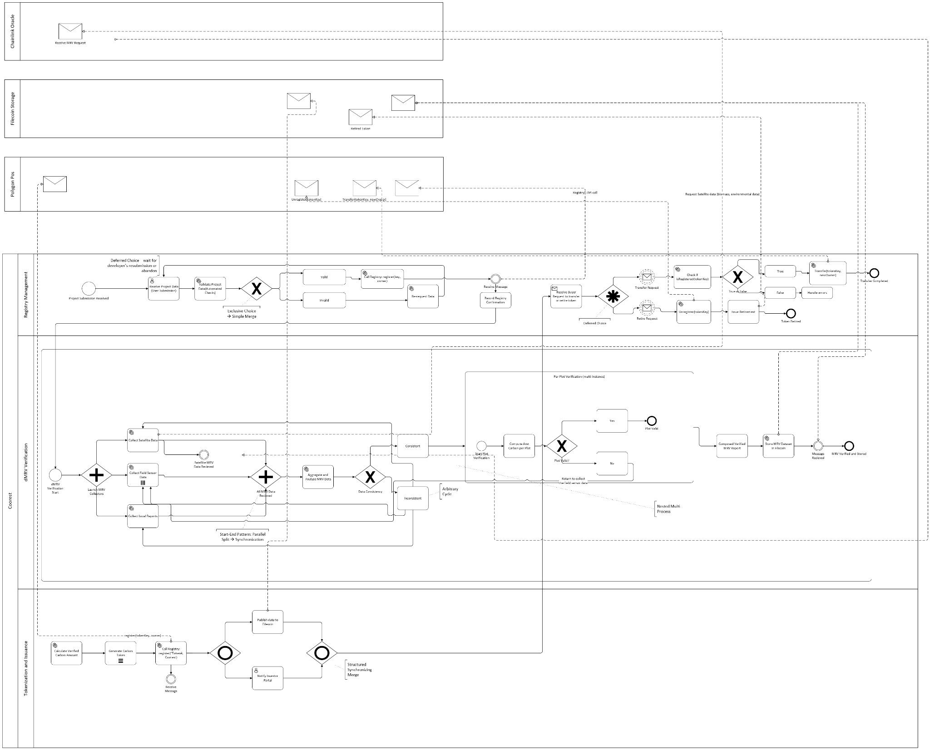
For a clearer image of the BP Diargam visit this link or see submission folder for diagram file.

5.0 Registry Use Description and Examples
As aforementioned, FileCoin is Coorest’s registry responsible for keeping track of tree and token owner ship. Each unique key is attached to an owner with corresponding data. The structure is as follows:

For a Tree:
Registry Use | Example
Initialize Tree: register(TreeID, Coorest) | Ex. 2 new trees are planted after Tree534  register(Tree535, Coorest)  register(Tree536, Coorest)
Purchase Tree: transfer(TreeID, new Owner) | Ex. John buys Tree2873  register(Tree2873, Coorest)  transfer(Tree2873, John)
Tree Carbon Data | Ex. A tree (Tree32, B) is able to mitigate 12 tonnes of carbon, this is stored under (Tree32, B)
Tree Sales Data | Ex. An apple tree (Tree12, A) makes $200, that will be stored under (Tree12, A).

For a Token:
Registry Use | Example
Initialize Token: register(TokenID, Owner) | Ex. (Tree236, Coorest) has mitigated X tonnes and has produce a carbon token  register(Token1298, Coorest)
Trade Token: transfer(TokenID, new Owner) | Ex. Coorest trade (Token1298, Coorest) to John  register(Token1298, Coorest)  transfer(Token1298, Coorest)
Burn Token: unregister(TokenID) | Ex. Coorest wants to burn (Token1298, Coorest)  unregister(Token1298)

6.0 Resource Classification Description
The resources in the Visio BPMN model are broken into organizational, external, and software resources. The organizational resource is Coorest since it owns and manages the entire carbon registry process. It is broken into three sublanes: registry management, digital, measurement, reporting, and verification(dMRV), and the tokenization and issuance of the carbon credits. The external resources are Chainlink Oracle, Filecoin, and Polygon PoS, as they all interact with Coorest via message flows. The software system is the API registry package that manages register(), transfer(), and unregister() in tokens that communicates between Coorest and the external resources to continuously update.

7.0 Activity Table
The activity table detailing the events of the BPMN Diagram created in Visio are outlined below.
Label | Description | Resources | Data Object
Recieve Project Proposal | Recieve Project Submission | Coorest - Registry Management | Project Proposal
Validate Project Data | Check if project data is valid. If invalid, return back to be processed | Coorest - Registry Management | Validate Project Data
Register Project | Call the registry API package to register(key, owner) | Coorest - Registry Management
Receive Confirmation | Receive the confirmation that the project has been registered | Coorest - Registry Management
Collect Satellite Data | Request environmental data from Chainlink Oracle | Coorest - dMRV Verification, Chainlink Oracle | Satellite Data
Collect Field Sensor Data | Gather MRV Data | Coorest - dMRV Verification | Field Sensor Data
Collect Local Reports | Collect data from local reports | Coorest - dMRV Verification | Local Data
Aggregate and Analyze MRV Data | Combine data from sensors and satellite to compute carbon metrics. If the data is invalid, loop back to data collection | Coorest - dMRV Verification, Chainlink Oracle
Compose Verified MRV Report | Create a report of the final verified data for token issuance | Coorest - dMRV Verification
Store MRV Dataset | Upload data to Filecoin for storage | Filecoin | MRV Dataset
Generate Carbon Tokens | Generate tokens on Polygon PoS based on the verified MRV report | Polygon PoS | Carbon Tokens
Transfer Carbon Tokens | Transfer tokens to new owner using transfer(tokenKey, newOwner) | Polygon PoS | Carbon Tokens
Retire Carbon Tokens | Unregister the tokens when the carbon offset is retired using unregister(tokenKey) | Polygon PoS | Carbon Tokens
Record Retirement Proof | Document the proof of carbon token retirement in Coorest’s system | Coorest - Registry Management | Retirement Proof

8.0 Web References
The table below details the Sources, URLS and their purpose in the report.
URL | Source & Explanation
https://coorest.io/wp-content/uploads/2023/01/Coorest_1-pager_2023.pdf | Coorest  One pager, summarizes the workflow.
https://coorest.io/partners/floodlight/ | Coorest  Explains how Floodlight works.
https://coorest.io/partners/chainlink/ | Coorest  Explains how Chainlink plays a role in the operation
https://coorest.io/partners/polygon/ | Coorest  Explains how Polygon POS plays a role in the operation
https://coorest.io/about/# | Coorest  About Us section, explain where the company originates and what their overarching goal/mission is.
https://coorest.gitbook.io/coorest-dapp-manual/ | Coorest  Easy ti follow manual on how all things coorest work.
https://www.youtube.com/watch?v=JojkoGf6s-U | Coorest  Summary Video on Coorest Carbon Mitigation Cycle
https://coorest-official.medium.com/coorest-is-more-than-just-a-technology-company-194d70e73053 | Medium  Provides information on how the carbon cycle works, how people make money, and how CO2 is mitigated
https://coorest.io/blockchain-and-the-voluntary-carbon-market/ | Coorest  Explains the basis of the blockchain and how it is a “voluntary carbon market”

9.0 Generative AI Use
Query: Can you explain what an arbitrary choice is and what it looks like in a Visio BPMN diagram?
Response: Absolutely! Let’s break this down carefully.

1. What an “arbitrary choice” means in BPMN

An arbitrary choice is a decision point in a process where the next step is not determined by strict rules or conditions—the process can continue along any one of multiple paths, potentially based on a non-deterministic choice or even a human decision without a clear algorithm.

In BPMN terms, this is usually represented as an Exclusive Gateway (XOR) where multiple outgoing paths exist.

Unlike a conditional choice, there may not be a specific condition defined, so the choice is “arbitrary” or left open.

Think of it like:

“After finishing this task, the system can continue to any of these next tasks. There’s no strict rule saying which one—someone or something decides arbitrarily.”

2. How it looks in a Visio BPMN diagram

In Visio BPMN:

Gateway Symbol: Use the diamond shape.

For an arbitrary choice, you usually use a plain diamond or an XOR gateway (marked with an “X”).

Outgoing Arrows: Draw two or more arrows coming out of the gateway.

Each arrow points to a possible next task.

If there are no conditions, you don’t label the arrows with conditions (or you can label them “arbitrary” or “any path” for clarity).

Tasks after the Gateway: These are your possible next steps after the arbitrary choice.

Visual Example:

[Task A]
|
▼
┌─────┐
│ XOR │ <-- arbitrary choice
└─────┘
/ \
▼ ▼
[Task B] [Task C]

Here, after Task A, the process can go to Task B or Task C, but there’s no defined condition—this is the “arbitrary choice.”

✅ Key Points to Remember

Arbitrary choice = no strict condition.

Usually represented by XOR gateway in BPMN.

Outgoing paths are unlabeled or generically labeled.

It’s different from a conditional choice, which has rules like [if X > 10 go here, else go there].

